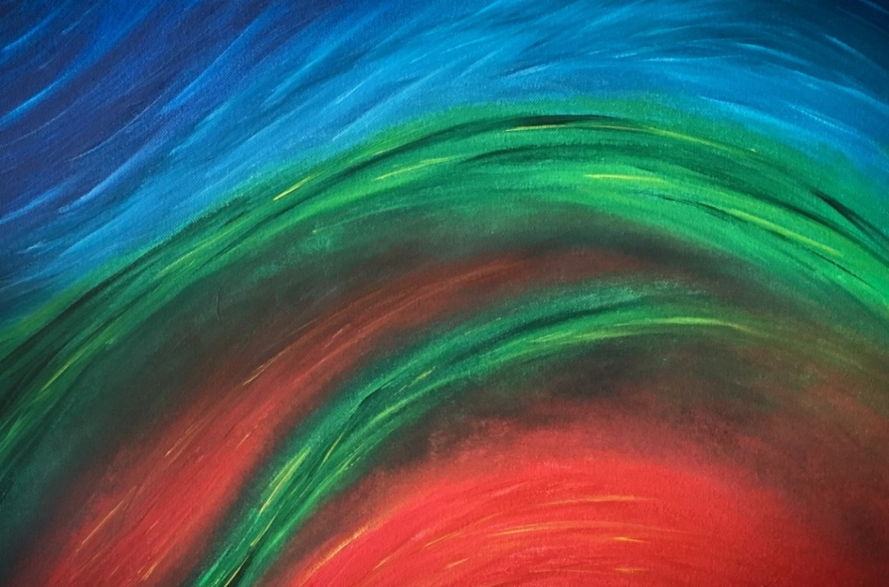

Colors of the Symphony

Resource Guide

This resource guide was created to help you prepare your students for the upcoming concert. Included are learning activities, short biographies of the composers, and information about each of the pieces that will be performed.

Many of the lessons utilize resources on the internet. All links provided in this document were active as of January, 2018.

Additional online resource materials have been provided at the end of the guide. We hope you enjoy the activities, and we’ll see you at the concert!

TABLE OF CONTENTS

WHO’S WHO?

Dwayne Corbin, Conductor 2

MEET THE COMPOSERS

Jim Stephenson 2

Wolfgang Amadeus Mozart 3
Antonin Dvorak 3

MUSICAL SELECTIONS

Marriage of Figaro, Overture 4

Compose Yourself! 4

SYMPHONY No. 8 in D major. Finale 5

LEARNING ACTIVITIES

Meet the Orchestra 5

Musical Color (Timbre) 7
Colors of the Symphony 8

ONLINE RESOURCES 10

1
WHO'S WHO?

CONDUCTOR

Dr. Dwayne Corbin
.
Conductor, educator, and percussionist are three of the many ways that Dr. Corbin has proven himself to be a successful and vital part of Northern California’s musical community. As Music Director of the Shasta Symphony Orchestra he has led inspiring traditional orchestral concerts as well as pops shows, chamber music concerts, choral/orchestra events, and “Symphony on the Beach” shows in partnership with the National Park Service. He also serves as the Resident Conductor of the North State Symphony, and conducts the 100-member Shasta College Symphonic Band.

Dr. Corbin is also Associate Professor of Instrumental Music at Simpson University. In the past, Dr. Corbin was the interim Assistant Conductor of the Juneau Symphony, conducted wind ensembles at Wheaton College and the University of Cincinnati, and led the Cincinnati Youth Wind Ensemble. In 2016, Dr. Corbin was a Conducting Fellow at the Fairbanks Summer Arts Festival, where he studied with Robert Franz. He has also studied at summer festivals and workshops hosted by the Cabrillo Festival, The National Symphony Orchestra, Northwestern University, Peabody Conservatory, and the New England Conservatory of Music.

Corbin has held the position of Principal Percussionist in the North State Symphony since 2006, and regularly presents jazz and classical recitals. Dr. Corbin’s composition Cage for One won first place in the 2009 Percussive Arts Society composition contest and is published by C. F. Peters. Corbin earned a Doctorate of Musical Arts in conducting from the University of Cincinnati College-Conservatory of Music, a Masters of Music in percussion performance from Central Washington University, and a Bachelor’s of Music Education from Wheaton College. He resides in Redding, CA with his wife and their two sons, Andrew and Peter.

MEET THE COMPOSERS

IM STEPHENSON
Compose Yourself!

Jim Stephenson is a contemporary musician / composer. He received his bachelor’s degree from the New England Conservatory of Music in 1990, and he performed for 17 years a professional trumpeter with the Naples Philharmonic (Florida). Jim got his start in composing by making musical arrangements for brass quintets. He moved on to arrangements for full orchestra, and then to composing original pieces.

Jim began composing full time in 2007. He writes music for orchestra, band, choir, and small ensembles (known as chamber music). Jim is a prolific composer, and has composed many concertos for specific performers. He states that he has written a concerto and a sonata for nearly every symphonic instrument.
2
Jim is planning to attend this year’s youth concert. We are extremely honored and excited about the opportunity to work with this amazing composer!

WOLFGANG AMADEUS MOZART
Overture Marriage of Figaro
January 27, 1756 – December 5, 1791

Wolfgang Amadeus Mozart was born in Salzburg, Austria. His father, Leopold, was a violinist and composer. As a three year old, he learned to play the piano by watching his older sister Maria Anna as she was taking lessons from their father. He composed his first piece of music when he was five, his first symphony when he was nine, and his first opera at the age of 13, at the request of an emperor. In 1762, when he was about 6, his father began traveling with Amadeus and his sister throughout Europe to perform for royalty, showing off their extraordinary talent.

Travel in the 1700s was an arduous task, with uncomfortable coaches, rutted and or muddy roads. There was no air conditioning in the summer or heat in the winter. Leopold would have to wait for an invitation from the aristocrats he visited before his children could perform. They were on the road for many months at a time.

At 17, Mozart became a court musician for the ruler of Salzburg. He didn't like it very well, but he composed a great many works during his tenure there. In 1781 he left his employment in Salzburg and moved to Vienna, where he lived for the rest his life. He worked freelance, and became well known as
a talented keyboard player and composer. While successful, he was a poor money manager. He lived a lavish lifestyle that caused his family to go deeply into debt when his income decreased during periods of little employment. When Austria became involved in the Austro-Turkish War, demand for musicians dropped, making his situation worse.

There is possibly no greater composer that Mozart. He was a true child prodigy, and an inspired composer, often composing as fast as he could write the notes, and produced over 600 works in his short lifetime. He composed in all different musical forms, including symphonies, concertos, chamber music, operas, masses, choral works.

Mozart was a confident and playful young man, and lived life fully. However he wasn't very tactful, and many people considered him arrogant and childish. He didn't quite fit in with the staid noble courts, and at times found it difficult to find employment. Mozart died young, at the age of 35.

ANTONIN DVORAK
SYMPHONY No. 8 in D major. Finale
September 8, 1841 – May 1, 1904

This material is quoted directly from the following website:
https://makingmusicfun.net/htm/f_mmf_music_library/hey-kids-meet-anton-dvorak.php

3

“Antonin Dvorak was born on September 8, 1841 in a small village in Bohemia, which is now part of the Czech Republic. He was one of seven children. Antonin’s parents recognized his musical talent and at the age of six he began his musical training. He studied music in Prague and graduated as an accomplished violin and viola player before he was 20 years old.

As a young adult, Antonin played viola in the Bohemian Provisional Theater Orchestra. When it became necessary to supplement his income with a teaching job, he left the orchestra to allow himself time to compose. While teaching, he fell in love with one of his students. In an attempt to win her heart, he wrote a song cycle called Cypress Trees.

In 1875, Dvorak moved to America to accept a position as head of the National Conservatory of Music. While in America he wrote his Symphony No. 9 “New World Symphony”. The New York Philharmonic’s premiere performance created a sensation at Carnegie Hall in 1893.

Antonin Dvorak died in Prague, Czechoslovakia on May 1, 1904

THE MUSICAL SELECTIONS

The selections below will be played at the upcoming concert.

THE MARRIAGE OF FIGARO, Overture

Marriage of Figaro is a comic opera, written in 1786. Mozart wrote the music. A different person, Lorenzo De Ponte, wrote the lyrics (words). The overture starts quickly, and sets the mood for the story to come. It is a crazy, wild ride about a man (Figaro) on the night before his wedding to his
sweetheart Susanna. In the story, there are secret plots to derail the wedding, disguises, and wild escapes, before everything ends happily.

Overtures often include elements from the songs that will be performed during the opera, somewhat like seeing previews of a new movie. However, the music heard in this overture is never played again during the entire opera.

COMPOSE YOURSELF!
Jim Stephenson

Compose Yourself! is a modern piece, written by Jim Stephenson in 2002. He was asked to write an interactive and fun piece introducing the instruments of the orchestra to students while he was working
for the Naples Philharmonic. His creation, Compose Yourself!, has entertained and educated young audiences over 350 times since 2002. The work introduces every instrument family, giving them a feature where you can hear them all working together, and the color that is painted when their sounds combine. Then every individual instrument is featured, so you can hear their unique color. The narrator for this concert will be Jim himself!

4

SYMPHONY No. 8 in D Major. Finale
Antonin Dvorak

The finale is an exciting movement. It begins with a fanfare of trumpets, then progresses to a beautiful and quiet melody played by the cellos. Enthusiastic variations on the beginning theme alternate with luxuriously beautiful sections played by the strings. The movement ends with an exciting chromatic coda, featuring brass, strings and tympanis. This movement also features almost every instrument on the melody at one point or another. Listen for how individual colors pop out here and there from the full orchestra sound!

Begin the link below at 25.00 minutes:
https://www.bing.com/videos/search?q=symphony+no.+8+in+d+major.+finale+you+tube&&view=detail&mid=C8F4E1E68D934FF73B79C8F4E1E68D934FF73B79&&FORM=VDRVRV

LEARNING ACTIVITIES

The following activities are designed to enhance your students' enjoyment and understanding of the upcoming concert. Included are selected videos of musicians performing on their instruments. Wherever possible, the performers in the videos are school age.

MEET THE ORCHESTRA

Lesson Overview:
The orchestra is made up of four families. Those are strings, woodwinds, brass, and percussion. This lesson introduces you to the four families of the orchestra and the sounds they make. Web links are provided to pictures of the instruments. Links are also provided for examples of musicians performing on the instruments.

Materials needed:
Computer with access to the internet.
Physical instruments and orchestra charts, if available. These may be available from the music specialist if your school has one.

Session 1:
Begin by asking your students what they know about a symphony orchestra. Do they know about the four instrument families, and some of the instruments in those families? There are four instrument families; Strings, Woodwinds, Brass, and Percussion. Refer to the websites listed below for pictures
that you can display on screen in your classroom. Perhaps some of your students already play an instrument and can share some information with their classmates.

5

String Family
Illustration of String Family:
http://4.bp.blogspot.com/-eK59icDNb5I/TqOnXaJGDiI/AAAAAAAACl4/6SmE7WdVbqM/s1600/string.png

Demonstration of strings:
Los Angeles Children’s Orchestra flash mob practice. The musicians are all children.
https://www.youtube.com/watch?v=zqpllAvZFdA

Wind Family
Illustration of Woodwind Family:
https://www.bing.com/images/search?q=orchestra+instrument+families+pictures&view=detailv2&id=E49F450F7DAAEC8852E5DB678C019661DFF28E59&ccid=pAOnp56i&simid=608025061681660527&thid=OIP.pAOnp56iFFd58gl7K992yQHaFb&mode=overlay&first=1&mediaurl=http%3A%2F%2F1.bp.blogspot.com%2F-4LKOovFzmzA%2FU_MwMM-bClI%2FAAAAAAAAABQ%2FumauKpmQ6gY%2Fs1600%2Fwoodwind.png&exph=1135&expw=1549&pivotparams=insightsToken%3Dccid_CWQ7toXW*mid_547FAD9637932462414F0F170BA2DC8DC815CAA3*simid_608019138079361509*thid_OIP.M09643bb685d6b12c6f2cda962cd5b7ecH0&iss=VSI

Mozart Wind trio, 2 clarinets, one bassoon, played by teenage boys:
https://www.bing.com/videos/search?q=mozart+woodwind+&&view=detail&mid=5361A8A6A37C052897F35361A8A6A37C052897F3&&FORM=VDRVRV

Flute trio performed by college students:
https://www.bing.com/videos/search?q=flute+trios&&view=detail&mid=621D3DB3EBFEF836F2F0621D3DB3EBFEF836F2F0&FORM=VRDGAR

Oboe trio with piano and cello, played by high school age students:
https://www.bing.com/videos/search?q=oboe+trios+trios&&view=detail&mid=78C204D7ECB6B5E8A8D178C204D7ECB6B5E8A8D1&&FORM=VDRVRV

Bassoon quartet, all young women:
https://www.bing.com/videos/search?q=bassoon+solo&&view=detail&mid=CA9436C09FCEE6273907CA9436C09FCEE6273907&&FORM=VDRVRV

Brass Family

Illustration of Brass family
https://www.bing.com/images/search?q=orchestra+instrument+families+pictures&view=detailv2&id=AE5341377AD1F411666E0BB286F8944D03536447&ccid=by1EUqSi&simid=608034639463124342&thid=OIP.by1EUqSiIlTxOUdSCHc27QHaFj&mode=overlay&first=1&mediaurl=http%3A%2F%2F1.bp.blogspot.com%2F-XP5kTcsa0Rc%2FUfXWbyUleoI%2FAAAAAAAAhuY%2FellNs-9d1Ro%2Fs1600%2Fbrass%2Bfam.png&exph=1127&expw=1502&selectedindex=1

6
Fanfare for the Common Man, by Arron Copland. Tympani, trumpets, French horns and trombones are featured in this classic piece.
https://www.youtube.com/watch?v=ZdqjcMmjeaA

Percussion Family

Illustration percussion family:
http://1.bp.blogspot.com/-bbEm-bLqBY8/UfXkPQfma1I/AAAAAAAAh54/jVrMIPHAb3A/s1600/percussion+fam.png

Orchestra seating chart

https://www.bing.com/images/search?q=orchestra+instrument+families+pictures&view=detailv2&id=41F006505F6088D0D2F46B9C0D30D180E5987910&selectedindex=10&ccid=zKwIlRoi&simid=608035266523759958&thid=OIP.zKwIlRoik5r5gRY-CW7ZoAHaFl&mode=overlay&first=1&mediaurl=https%3A%2F%2Fs-media-cache-ak0.pinimg.com%2Foriginals%2Fcc%2Fac%2F08%2Fccac08951a22939af981163e096ed9a0.jpg&exph=506&expw=670

Session 2:
Watch The Remarkable Farkle McBride (link below) on YouTube or listen on a CD. This 15-minute story is a humorous and informative tale of one child's exploration of instruments in the orchestra. The story can be played in its entirety, or in sections. As the children are listening to the tale, refer to the orchestra chart if you have one, or to the above links.

https://www.bing.com/videos/search?q=the+remarkable+farkle+mcbride+you+tube&view=detail&mid=BB3DE08DAC71FECACA18BB3DE08DAC71FECACA18&FORM=VIRE

Younger students may also enjoy following 6 year old George as he meets members of the Sydney (Australia) Youth Orchestra, and learns about their instruments.
https://www.youtube.com/watch?v=M0Jc4sP0BEE

Review the images of the instrument families. Discuss how the instruments in each family are “related” and what that means in terms of how each instrument produces sound. If real instruments can be brought in to the classroom, let the students explore how each is made and how each produces sound.

MUSICAL COLOR (TIMBRE)

The upcoming concert will be about the “colors” of the symphony. In music, timbre is the distinctive tone, quality or color of an instrument or voice. Instruments can be identified by their timbre,

7
regardless of pitch or volume. The violin has a very different timbre than a trumpet, for instance, even when they are playing the same note. Your voice has a different timbre than the voice of your sibling or your best friend. The timbre or color of an instrument is very important when a composer writes a piece of music.

Lesson overview
The following game will help students understand the concept of timbre.

Materials needed:
Computer with internet access

Session 1
Can the students, with eyes closed, identify an individual who is singing or speaking by the
sound (timbre) of their voice?

Have all students close their eyes, then select a student to say the current day and date, such as “Tuesday, January 30”. Repeat 2 more times. Can each student be identified by voice alone?

Select four students to stand before the class. Have them say together the current day and date again. Instruct their classmates to close their eyes while they listen to determine what makes the voices sound different or similar. The students should then rearrange themselves until similar voice timbers are together.

Invite the students to discuss what may have been the reasons for differences in timbre, tone color.

Session 2
Refer to the selections provided in the previous section and engage students in a discussion of how the timbres are different for each instrument family, and the instruments within each of the families.

COLORS OF THE SYMPHONY

What are the colors of the Symphony? When an artist decides to create a picture, she/he has many choices. What will she portray? Will it be a mountain, animals, or perhaps something abstract? What tools will the artist use to make the picture? Paint, chalk pastels, crayons, charcoal, colored pencils will all work, but what most reflects what the artist wants in the final picture?

Composers are faced with similar choices when they write a composition. They have an idea in mind, then use different instruments to best convey that idea. As you learned earlier, instruments have different timbres. Many composers have used flutes to represent the sound of birds, for instance. Would the sound of a trombone make a person think of birds?

8

PAINT YOUR SYMPHONY EXPERIENCE

Lesson overview
Students will paint their impression in watercolor of their youth concert experience.

Materials needed:
Marking pens or colored pencils, or crayons
Water color paints and brushes and paper

Session 1:
Before the concert:
.
Play the following selection of the Marriage of Figaro overture for the students. Discuss what they hear, which instruments they think are playing, and the mood or ideas the piece conveys. Have them consider what they might draw as they listen to the music. Provide students with paper and colored pencils or crayons. Play the overture again a few times while the students create their pictures. Encourage them to use lots of color.
https://www.bing.com/videos/search?q=overture+marriaage+of+figaro+you+tube&view=detail&mid=EDA347A01434766E696FEDA347A01434766E696F&FORM=VIRE

Session 2:

After the concert:
(This should be done the same day or the day following, while the experience is still fresh)

Discuss with your students the experiences they had during the concert. Include such things as the bus trip, what the theater was like, what the stage looked like to them, the musicians, the conductor, the narrator, everything. Discuss what kinds of feelings they had as they listened to the music.

Provide watercolor paints, brushes and paper to the students and instruct them to repeat the exercise, this time from memory alone. Have the students focus on just one aspect of their concert experience. It can be realistic or abstract.

When they are done, invite them to compare their first picture with the paintings. How did the full concert experience affect their artwork? Did they include more detail? How did the colors change? Were their creations more concrete or more abstract?

At the conclusion of these lessons and after their concert experience, your students should have a better understanding of how the individual colors of each instrument contribute to the rich tapestry of sound in a full orchestra. The online resources provided in the next section will help you if you wish to explore more musical concepts with your students.

9

ONLINE RESOURCES (as of Jan 2018)

The following websites have lots of music learning activities for further exploration.

Carnegie Hall
Music Educator’s Toolbox
https://www.carnegiehall.org/Education/Educators/Music-Educators-Toolbox

Dallas Symphony Orchestra
https://www.mydso.com/dso-kids

Arts Edge – from the Kennedy Center
http://artsedge.kennedy-center.org/educators.aspx

San Francisco Symphony website for children
http://www.keepingscore.org/education

Nashville Symphony
https://www.quavermusic.com/Default.aspx

National Core Arts Standards
http://www.nationalartsstandards.org/

10

